A000-China-Warrior-Yama-bronze-T'ang-618–907 CE

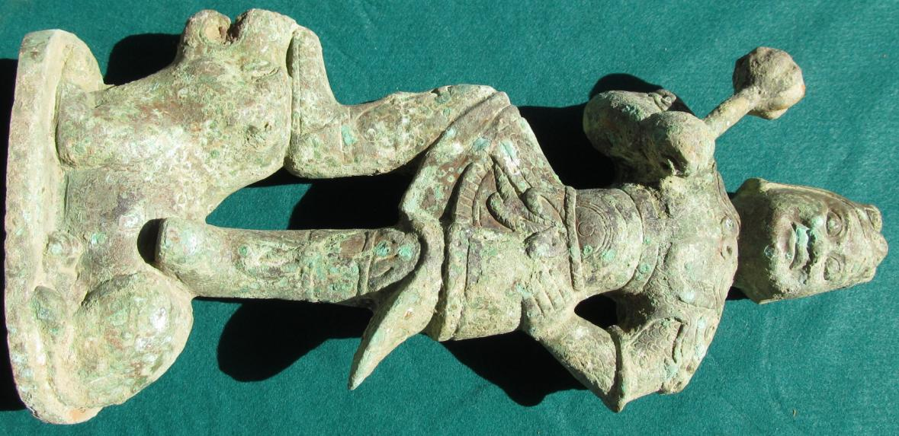

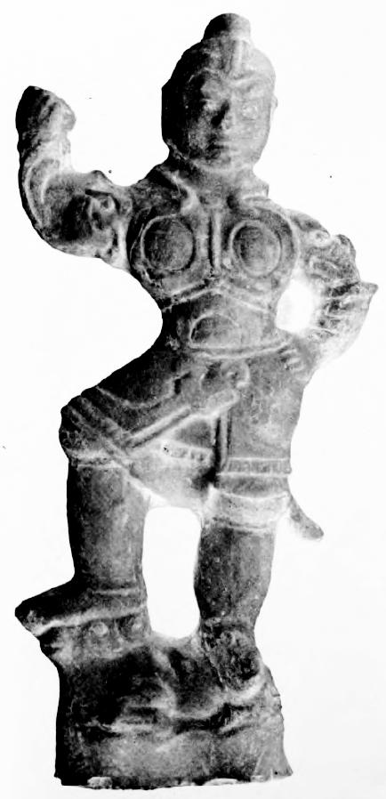

Fig. 1, left: Yama, bronze casting, T'ang dynasty, 8th century CE, possibly Shaanxi or Honan Province; fig. 2, right, stylistically similar T'ang dynasty (618-906 CE) clay figurine of Yama from Honan Province with only the mace missing, height 39 cm. in the Field Museum of Natural History, cat. no.117989 (Laufer 1914: 467).

Yama in Vedic mythology is the first ancestor, who is also worshipped as the god of the underworld and death. In Sanskrit Yama (यम) can be interpreted "twin" (Puhvel 1989: 285-286). In Buddhism, Yama is a *dharmapāla* or wrathful god, the judge of the dead and defender of the *dharma*. Though *dharmapālas* have a terrifying appearance and countenance, they are all bodhisattvas or buddhas, who embody compassion and only act in a wrathful way for the benefit of sentient beings.*Dharmapālas* preside over *naraka*, which literally means "[the underworld] of man" in Buddhism, the realm of the cycle of rebirth (see *Devadūta-sutta* ofthe Pāli Canon) which is not eternal but certainly protracted and may involve tortures and torments. In *naraka* the being that is brought there by the law of *karma* remains there until its negative *karma* has been expended.

Yama as a *dharmapāla* was developed by the esoteric teachings of Vajrayana Buddhism in India and were brought into China via the Silk Road by three great masters: [Śubhakarasimha](http://en.wikipedia.org/wiki/Subhakarasimha) (637－735), Vajrabodhi (671–741), and Amoghavajra (704–774) (Baruah 2008: 170). The travels of these masters suggest where the centers of esoteric Buddhism originated and where the bronze and ceramic Yama figurines were first envisioned in T'ang China. For instance, by AD 720 Vajrabodhi was ensconced in the Jianfu Temple at the Chinese capital, Chang'an (Xian in Shaanxi Province), accompanying him was his famous disciple, Amoghavajra (Goble 2012). Geoffrey Goble has suggested that Amoghavajra should be recognized as the most influential of the three who was able to gain rare T'ang court patronage of Buddhism by a non-Chinese monk among the ruling élite in the second half of the eighth century.

This bronze casting of Yama follows eighth century CE stylistic T'ang rules of replication of Yama's attributes of being both wrathful and compassionate. His facial expression conveys a positive attitude to the one being judged, supplemented by a tentativeness emphasized by his left arm akimbo suggesting a measure of detained compassion. However, he wears the helmet of a tiger's skull, a powerful symbol of might and shamanic antiquity. Meanwhile his wrathful nature is suggested by his raised right hand menacing a mace which he is wielding with authority lest his detained compassion is not heeded.

His garb is that of a fully dressed T'ang warrior with high leather boots cinched below the knee. His upper torso is clad in scale armor over a flaring kilt with a tightly fitting cuirass around his chest and a cord belt cinched at the waist with a large loop. He stands on the back of a recumbent tiger (?) to emphasize his power over a mighty beast with his right foot on its head and his left foot on its croup. This example illustrates the T'ang style of scale armor and represents one of the best examples of understanding its introduction and development.

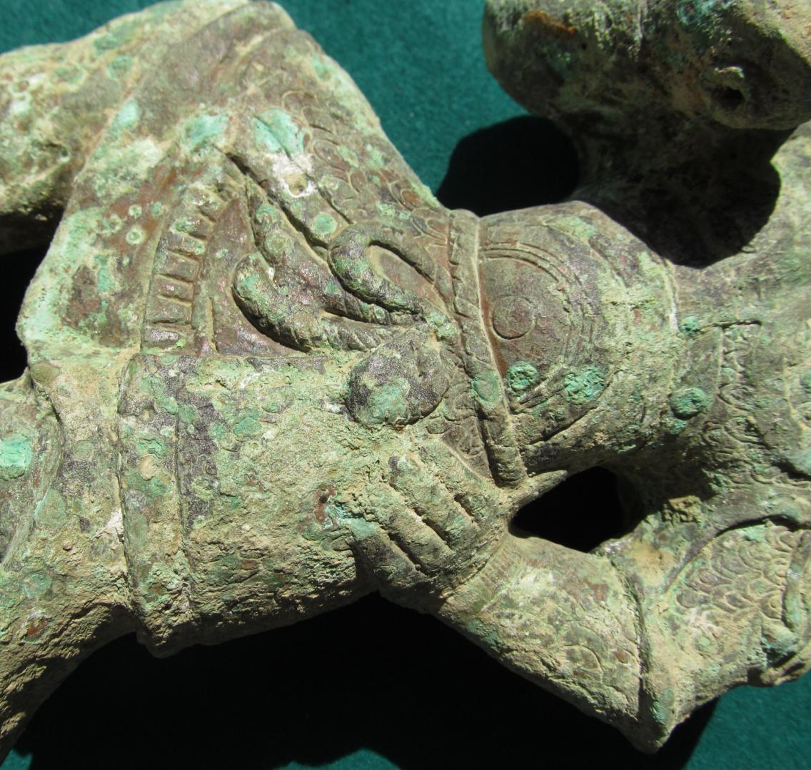

Fig. 3. detail of cuirass, scale armor construction, kilt, corded belt in a large loop at waist.